1. Configuring the Content Search Web Part:
   1. From the Pages library add the Web Part Page to the libraries available Content Types:
      1. From the site click on the Site Actions Cog, and choose “Site Contents” from the drop down menu

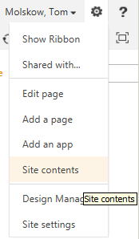

* + 1. From the Site Contents page click on the “Pages” library icon.

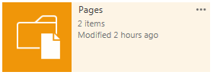

* + 1. From the Pages library click on the Library tab, and then click on the Library Settings icon.
    2. From the Pages Settings page, in the Content Types section, click on the “Add from existing content types” link.
    3. From the Settings Add Content Types page, under Available Site Content Types, choose Web Part Page, and then click the Add button.

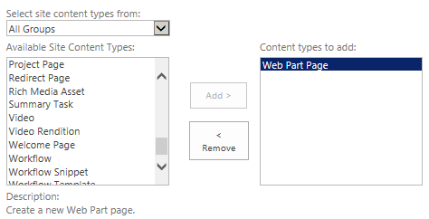

* + 1. Finally click the OK button, this will return you to the Pages Settings page.
    2. Click on the word “Pages” in the header of the page, this will return you to the Pages library’s main page.
  1. Create a Web Part Page:
     1. In the Menu Ribbon click on the Files tab
     2. From the Files tab click on the New Document icon and from the drop down choose Web Part Page

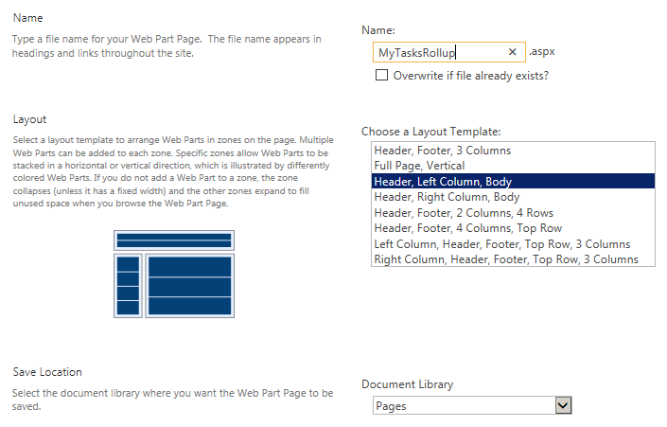

* + 1. From the Site Contents New Web Part page take the following actions:
       1. Name: MyTasksRollup
       2. Layout: Header, Left Column, Body
       3. Document Library: Pages
       4. Click on Create
       5. This will bring you to the Web Part page
  1. Add the Configurations and Code for the MY Tasks Rollup solution:
     1. From the new MyTasksRollup page, click on the “Add a Web Part” link in the Header Zone, this will open the “Insert a Web Part” pane at the top of the page
     2. In the Categories section scroll down and click on the “Content Rollup” section
     3. In the Parts section click on the Content Search web part

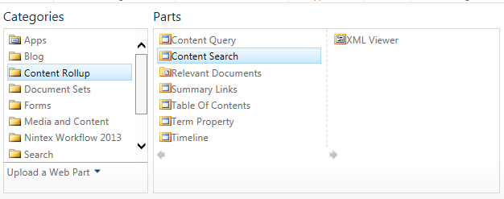

* + 1. Finally, at the far right of the “Insert a Web Part” pane, click “Add”; this will close the Insert a Web Part pane
    2. Now, with the Content Rollup web part added, click on the (very!) small drop down arrow in the web part, and from the drop down choose the “Edit Web Part” menu item; this will open the Edit Web Part pane on the right
    3. From the Edit Web Part pane take the following actions:

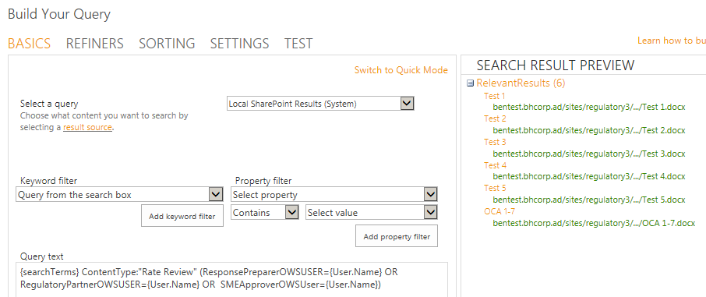

* + - 1. Click on the “Change Query” button
      2. From the “Build Your Query” pop-up window, in the query text section, paste the code below (overwriting any existing code):

{searchTerms} (ContentType:"Rate Review" (RegulatoryPartnerOWSUSER:{User.Name} OR SMEApproverOWSUSER:{User.Name} OR ResponsePreparerOWSUSER:{User.Name}) AND ( ReviewTaskStatusOWSCHCS<>Final AND ReviewTaskStatusOWSCHCS<>Served)) OR (ContentType:"Task” AssignedTo:{User.Name} AND PercentCompleteOWSNMBR<>1)

* + - 1. Click on the “Test query” button, some search results should appear
      2. Finally click on the OK button, this will close the Build Your Query pop-up window
      3. In the “Number of items to show” input box enter the number 10
      4. In the Display Templates section, under the Control header, from the drop down choose “My Task Rollup List with Paging New”
      5. In the Display Templates section, under the Item header, from the drop down choose “My Task Rollup New”
      6. Finally click the “OK” button, this close the Edit Web Part pane
      7. From the Web Part page, in the ribbon, click on the “Stop Editing” button
      8. This completes the configuration of the My